**KINDERGARTEN**

**Holiday homework for winter vacation**

**(2015-2016)**

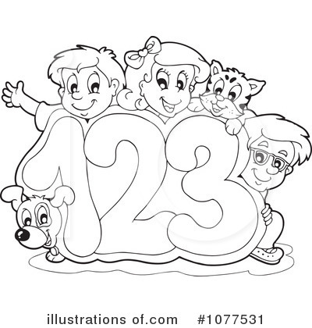

डी. ए.वी पब्लिक स्कूल

सेक्टर-6 द्वारका

रेफ़रन्स न. ………………….. दिनाक …………………

नाम ……………………. कक्षा…………………..

चित्र देख कर अक्षर लिखो

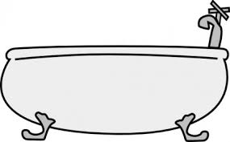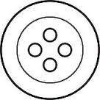





रिक्त स्थान भरो

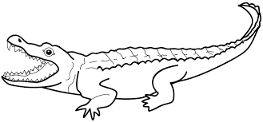 मग 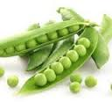 टर

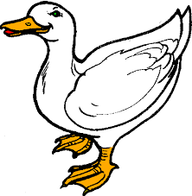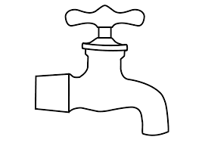

ल बत

लय वाले शब्द

महल - चमक-

नरम - सड़क -

डी. ए.वी पब्लिक स्कूल

सेक्टर-6 द्वारका

रेफ़रन्स न. ………………….. दिनाक …………………

नाम ……………………. कक्षा…………………..

**शब्द लिखो**

**दो वर्ण तीन वर्ण चार वर्ण**

|  |  |  |
| --- | --- | --- |
|  |  |  |
|  |  |  |
|  |  |  |
|  |  |  |

**DAV Public School**

Sector VI,Dwarka,New Delhi

Ref.no. _________________________ Date _________

**Subject- English**

Name _________________________ Class- Pre Primary ____

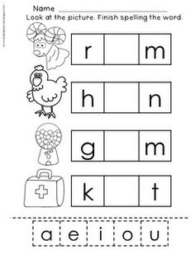**Write the correct vowel in the given box to make a word.**

**DAV Public School**

Sector VI,Dwarka,New Delhi

Ref.no. _________________________ Date _________

**Subject- English**

Name _________________________ Class- Pre Primary ____

**Look at the picture & make a word from the given letters.**

|  |  |  |
| --- | --- | --- |
| **Image result for cat clipart black and white** | **c**  **a**  **t**  **m**  **i**  **x** | **cat** |
| Image result for cricket bat clipart black and white | b  **a**  **t**  **k**  **o**  **j** |  |
| **Image result for jam clipart black and white** | c  **i**  **t**  **m**  **a**  **j** |  |
| Image result for fan clipart black and white | f  **e**  **p**  **n**  **a**  **t** |  |

**DAV Public School**

Sector VI,Dwarka,New Delhi

Ref.no. _________________________ Date _________

**Worksheet**

**Subject- EVS**

Name _________________________ Class- Pre Primary ____

1. **Draw the tools of each helper in the space provided?**

[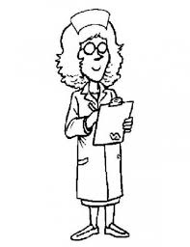](http://www.google.co.in/url?sa=i&rct=j&q=&esrc=s&source=images&cd=&cad=rja&uact=8&ved=0ahUKEwitt-6O7fnJAhXHTo4KHSUeDgoQjRwIBw&url=http://freecoloringpages.co.uk/?q=community%20helpers%20tools&bvm=bv.110151844,d.c2E&psig=AFQjCNEoHp6TxdbrAwhAxdryKGZ0DP0lgw&ust=1451230250582482)

[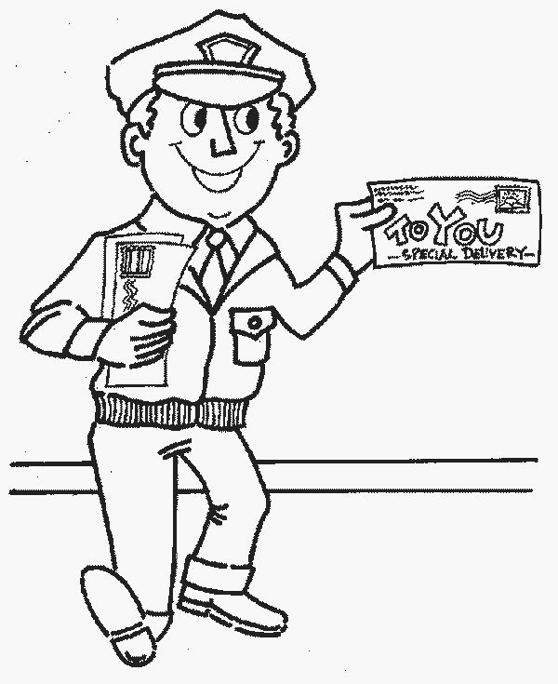](http://www.printcoloringpages.in/mailman-coloring-pages/)

**[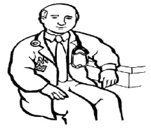](http://www.google.co.in/url?sa=i&rct=j&q=&esrc=s&source=images&cd=&cad=rja&uact=8&ved=0ahUKEwigqOWd7PnJAhXNUo4KHSJfDCIQjRwIBw&url=http://freecoloringpages.co.uk/?q=community%20helpers%20masks&bvm=bv.110151844,d.c2E&psig=AFQjCNEoHp6TxdbrAwhAxdryKGZ0DP0lgw&ust=1451230250582482)**

**[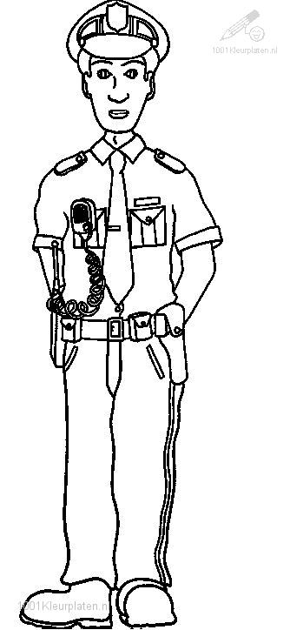](http://www.google.co.in/url?sa=i&rct=j&q=&esrc=s&source=images&cd=&cad=rja&uact=8&ved=0ahUKEwiLud2D7vnJAhVOWI4KHbZeAg4QjRwIBw&url=http://educ-fis.blogspot.com/2014/12/06-de-diciembre-se-recuerda-el.html&bvm=bv.110151844,d.c2E&psig=AFQjCNEoHp6TxdbrAwhAxdryKGZ0DP0lgw&ust=1451230250582482)**

1. **Match the animals with their homes?**

[](https://www.google.co.in/url?sa=i&rct=j&q=&esrc=s&source=images&cd=&cad=rja&uact=8&ved=&url=https://www.coloriage-pour-colorier.com/animaux/poisson/&bvm=bv.110151844,d.c2E&psig=AFQjCNFFAxvTua7RYngEFcg9Rvwu8ECtDQ&ust=1451231338066511) [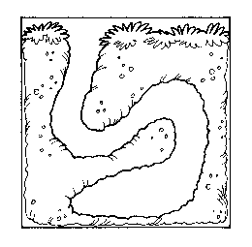](http://www.google.co.in/url?sa=i&rct=j&q=&esrc=s&source=images&cd=&cad=rja&uact=8&ved=0ahUKEwis0ciG8vnJAhUSB44KHVYQDFAQjRwIBw&url=http://printablecolouringpages.co.uk/?s=burrow&page=1&bvm=bv.110151844,d.c2E&psig=AFQjCNH8ix9IVffs7S7LCMJuO1AYwP9f6g&ust=1451231795434387)

[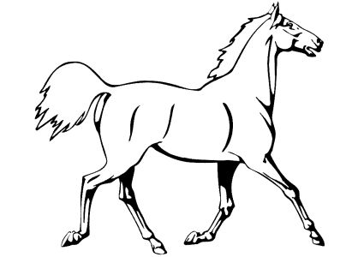](http://www.google.co.in/url?sa=i&rct=j&q=&esrc=s&source=images&cd=&cad=rja&uact=8&ved=0ahUKEwian4uf8PnJAhWNBI4KHZXwDWwQjRwIBw&url=http://www.topglobus.ru/besplatno-raskraski-dlja-detej-zhivotnye-koni-loshadi-zebry&bvm=bv.110151844,d.c2E&psig=AFQjCNFFAxvTua7RYngEFcg9Rvwu8ECtDQ&ust=1451231338066511) [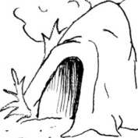](http://www.google.co.in/url?sa=i&rct=j&q=&esrc=s&source=images&cd=&cad=rja&uact=8&ved=0ahUKEwi_z6XX8vnJAhWHkY4KHezyB2YQjRwIBw&url=http://www.funfonix.com/clipart4.php&bvm=bv.110151844,d.c2E&psig=AFQjCNGaunzWxNdQ3hS4IhpYp5lQaGufUQ&ust=1451231978688681)

[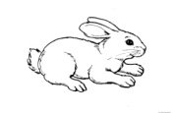](http://www.google.co.in/url?sa=i&rct=j&q=&esrc=s&source=images&cd=&cad=rja&uact=8&ved=0ahUKEwiQ1cjs8PnJAhXLJI4KHSnzCt0QjRwIBw&url=http://intleadsolutions.com/coloring-pages-of-animals-pictures-of-animals-for-coloring-free-coloring-page-2-17602/&bvm=bv.110151844,d.c2E&psig=AFQjCNFFAxvTua7RYngEFcg9Rvwu8ECtDQ&ust=1451231338066511) [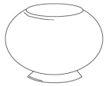](http://www.google.co.in/url?sa=i&rct=j&q=&esrc=s&source=images&cd=&cad=rja&uact=8&ved=0ahUKEwio8oeU8_nJAhVFCo4KHRuqCUoQjRwIBw&url=http://freecoloringpages.co.uk/?q=empty%20dog%20bowl&bvm=bv.110151844,d.c2E&psig=AFQjCNExSYE3Rq_P96Tjcicw25yLTxvHeQ&ust=1451232110625805)

[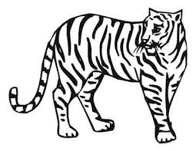](http://www.google.co.in/url?sa=i&rct=j&q=&esrc=s&source=images&cd=&cad=rja&uact=8&ved=0ahUKEwis1sWP8fnJAhULkI4KHYATAZUQjRwIBw&url=http://colouringpictures.info/animals-colouring-pictures.php&bvm=bv.110151844,d.c2E&psig=AFQjCNFFAxvTua7RYngEFcg9Rvwu8ECtDQ&ust=1451231338066511) [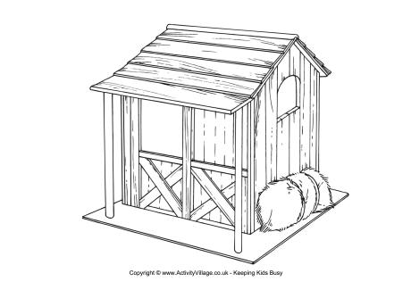](http://www.google.co.in/url?sa=i&rct=j&q=&esrc=s&source=images&cd=&cad=rja&uact=8&ved=0ahUKEwi1ifyl8vnJAhUCC44KHanTDVMQjRwIBw&url=http://www.activityvillage.co.uk/stable-colouring-page&bvm=bv.110151844,d.c2E&psig=AFQjCNFAO9e3n2MyKeZesXXCgEaflXKyMg&ust=1451231894088467)

1. **Label the different parts of a plant?**

**[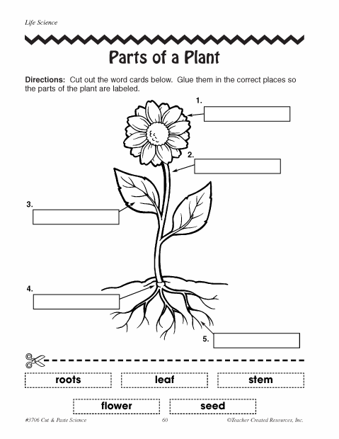](http://www.google.co.in/url?sa=i&rct=j&q=&esrc=s&source=images&cd=&cad=rja&uact=8&ved=0CAcQjRxqFQoTCLrfwN7Y8sgCFYEylAodUFII2w&url=http://freecoloringpages.co.uk/?r=parts+of+plant&psig=AFQjCNEVd7CcfLBKBmQhHrvCe5fm-y6LZw&ust=1446586365649355)**

1. **Draw a circle on living things and cross the non living things?**

[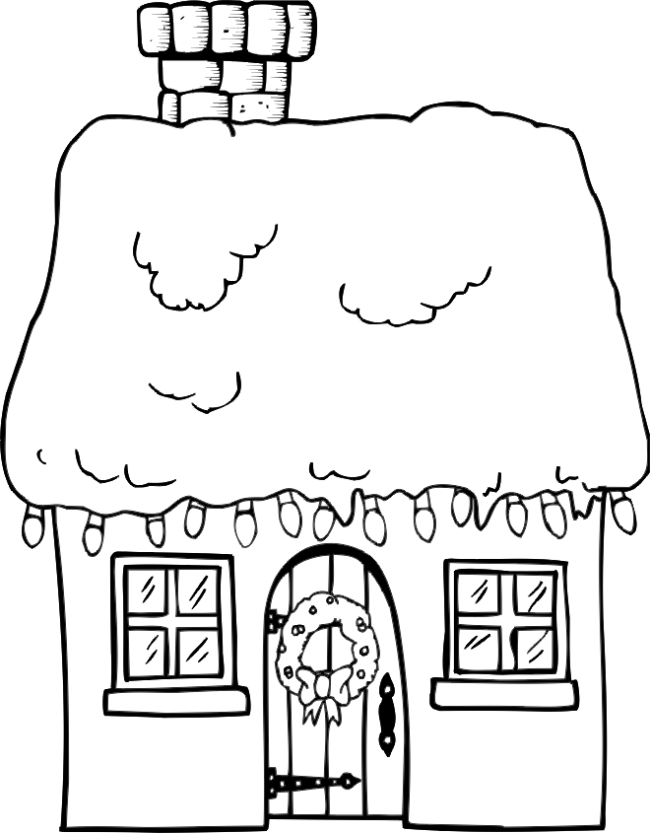](http://www.google.co.in/url?sa=i&rct=j&q=&esrc=s&source=images&cd=&cad=rja&uact=8&ved=0ahUKEwisg_SL9_nJAhWKPo4KHQhbChkQjRwIBw&url=http://intleadsolutions.com/free-printable-house-coloring-pages-for-kids-5-27950/&bvm=bv.110151844,d.c2E&psig=AFQjCNGMGUpLhrNNK3-SXzrm9oxYIImaqQ&ust=1451233187980689) [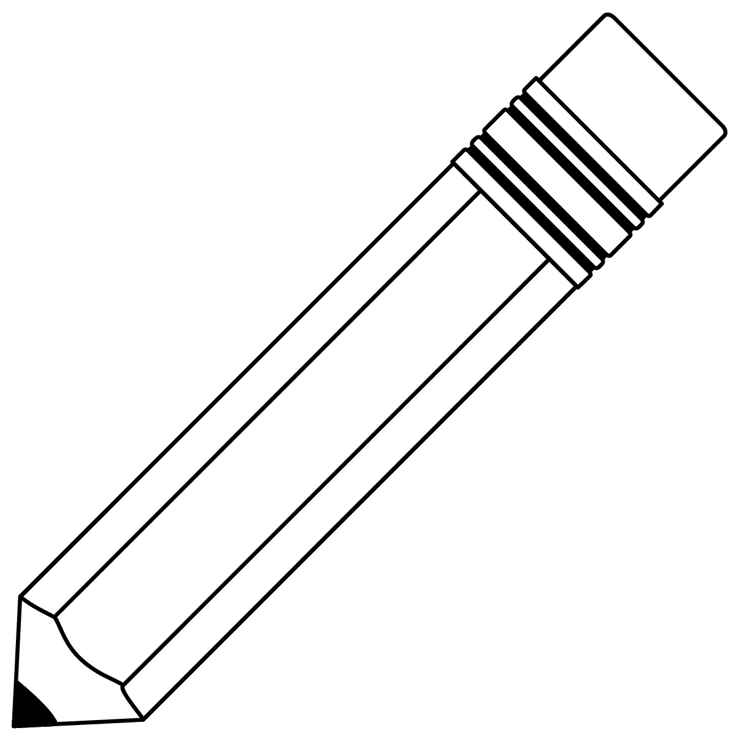](http://www.google.co.in/url?sa=i&rct=j&q=&esrc=s&source=images&cd=&cad=rja&uact=8&ved=0ahUKEwj908ip9_nJAhWFuhQKHbw-ARMQjRwIBw&url=http://www.bestcoloringpagesforkids.com/pencil-coloring-pages.html&bvm=bv.110151844,d.c2E&psig=AFQjCNElq2B3Ezm9bRBTy_zR6Ta93pwihg&ust=1451233238497375) [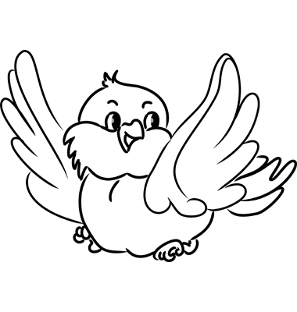](https://www.google.co.in/url?sa=i&rct=j&q=&esrc=s&source=images&cd=&cad=rja&uact=8&ved=0ahUKEwikhOm-9_nJAhUJShQKHTVqC78QjRwIBw&url=https://www.vectorstock.com/royalty-free-vector/cartoon-bird-vector-1105953&bvm=bv.110151844,d.c2E&psig=AFQjCNEyq80qZS6Ze55qNExWEiRdIZiPNw&ust=1451233299656810) [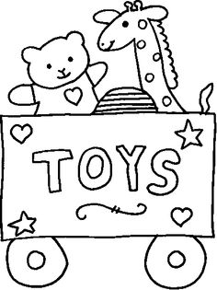](https://www.google.co.in/url?sa=i&rct=j&q=&esrc=s&source=images&cd=&cad=rja&uact=8&ved=0ahUKEwjuxK3o9_nJAhWGcRQKHXFTBl4QjRwIBw&url=https://www.pinterest.com/deboragioia/toys/&psig=AFQjCNGxwWoOgNlFbEYb9Vb3-6P1T-oCeg&ust=1451233384223196) [](http://www.google.co.in/url?sa=i&rct=j&q=&esrc=s&source=images&cd=&cad=rja&uact=8&ved=0ahUKEwie166C-PnJAhWI0xQKHQtWC5oQjRwIBw&url=http://cliparts.co/clipart/2404683&psig=AFQjCNFJKbIuYEjpQyHu9wpnYCLxGyoAtw&ust=1451233439993166)

1. **See the below pictures and write W for water transport, L for land** **transport and A for air transport?**

[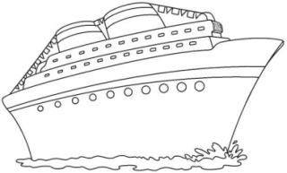](http://www.google.co.in/url?sa=i&rct=j&q=&esrc=s&source=images&cd=&cad=rja&uact=8&ved=0ahUKEwiovovk-fnJAhUOWI4KHYknAoMQjRwIBw&url=http://fichasparapintar.com/dibujos-yate-para-pintar&psig=AFQjCNFN7vOFGg6UW-o2z4j7nEZWBl_6BA&ust=1451233916942666)

[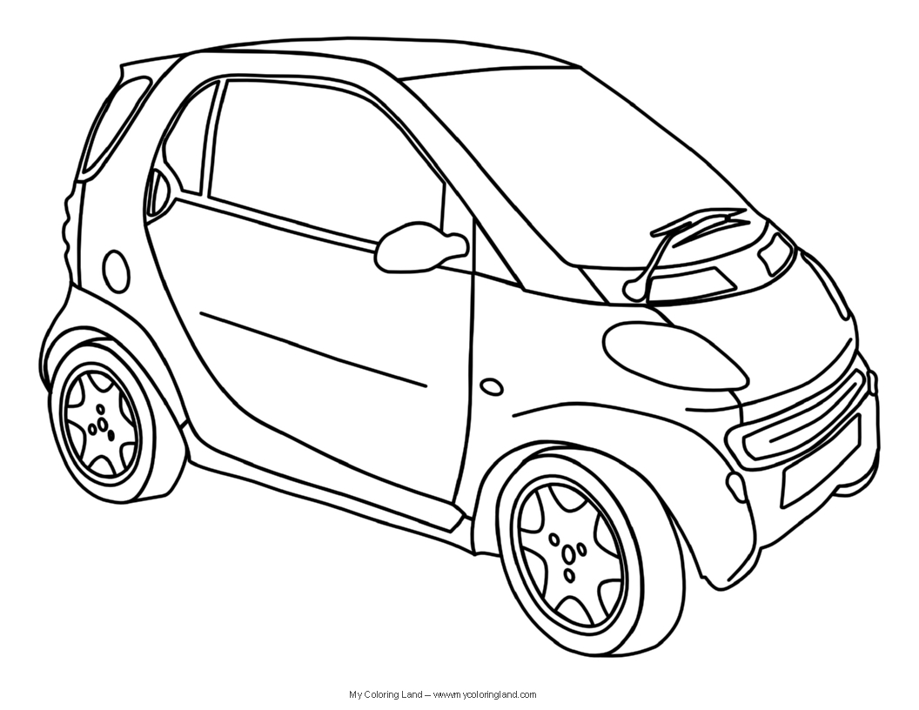](http://www.google.co.in/url?sa=i&rct=j&q=&esrc=s&source=images&cd=&cad=rja&uact=8&ved=0ahUKEwiUyqDO-fnJAhXGGY4KHdhaAckQjRwIBw&url=http://mycoloringland.com/coloring-pages/cars&psig=AFQjCNGFDvFyGIYvBkxxnnThIBGeXM7OMQ&ust=1451233856300025)

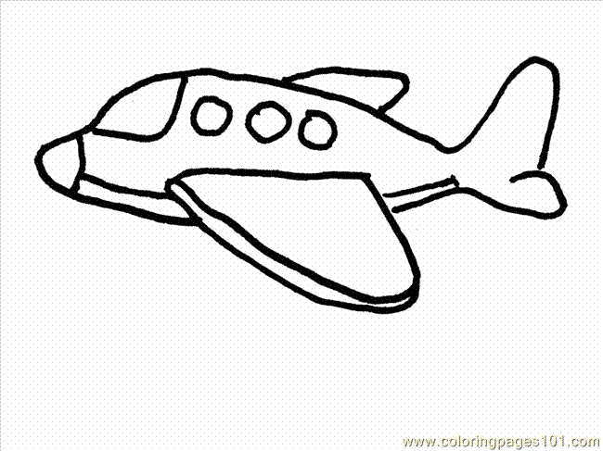

**D A V Public School**

**Sector-6 Dwarka, New Delhi-110075**

**Date-_____________**

**WORKSHEET**

**Subject:** Mathematics

Name-____________ Class-Pre-Primary

**Q1. Fill the missing numbers.**

1. **59 __________ _________ 62 ___________ __________**
2. **88,89 ___________ ____________ ___________ 93**

**Q2. What comes**

**Before After Between**

**________ 74 46 ________ 39 _________ 41**

**________ 30 51 ________ 79 __________ 81**

**Q3. Solve.**

**13 16 11 14 17**

**+ 5 - 8 + 7 - 4 - 0**

**_______ _______ ________ _______ _____**

**Q4. Mental Maths**

1. **10 - 5 = ________**
2. **12 - 6 = ________**
3. **13 + 4 = ________**

**Q5. Concept of tens and ones.**

**9 30 96**

T O T O T O

Q6. Draw the beads on abacus.

T O T O T O

______________56 __________40 ______6

**Q7. Draw two objects of each**

1. **Light weight**

**_________________ ____________________**

1. **Heavy weight**

**___________________ ______________________**

**Join the dots from 1 to 50 in sequence and complete the picture. Now color it.**

