DAV PUBLIC SCHOOL KHERA KHURD / BUDHPUR

School Website : davpskherakhurd.com , School Tel No. 01127844245 , 01127201930

SUMMER BREAK HOLIDAYS HOMEWORK (2018-19)

Class VIII

English

HOLIDAY HOMEWORK WILL BE ASSESSED FOR 5 MARKS Each subject

1. Writing a self composed poem on “ My Mother”
2. Read the unit “Changing Times” of “ My English Reader” and write a speech on “Impact of Media on Teenagers” in about 100-150 words

(Note- H.W. must be done in your activity file.)

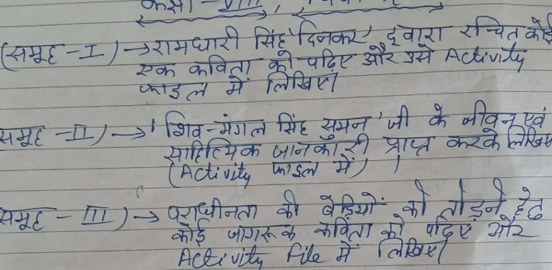 **Hindi**

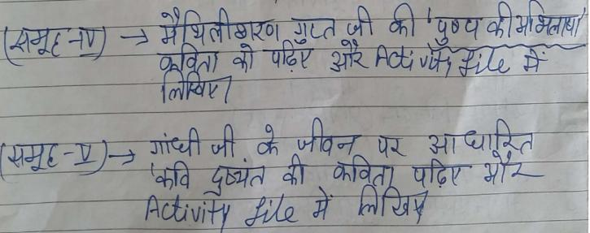

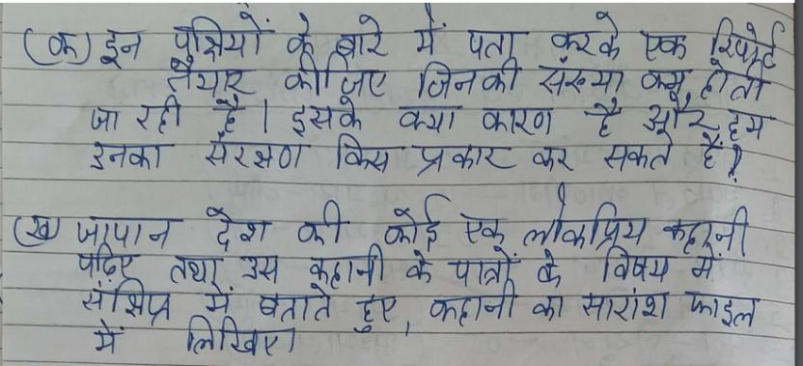

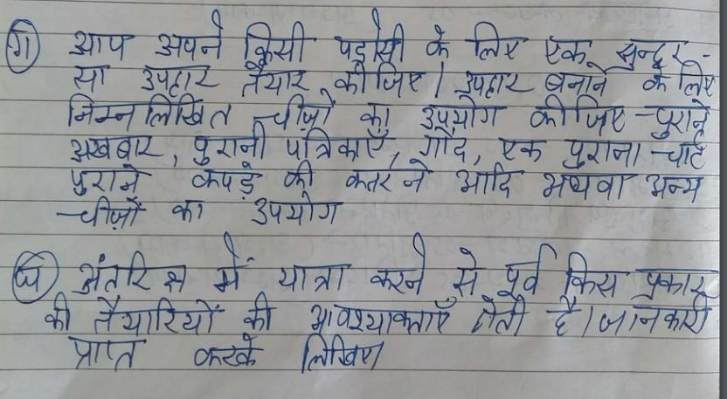

**Maths**

1) ACTIVITY:

List your P T1 marks in various subjects in tabular form and represent

it in the form of bar graph by paper cutting and pasting.---------------(2.5 M)

2) PROJECT:

Create a life history of Indian Mathematician and his contribution in

the field of Mathematics. .------------------------------------------ (2.5 M)

i) Group 1 Aryabhatta

ii) Group 2 Srinivasa Ramanujan

iii) Group 3 Brahmagupta

iv) Group 4 Bhaskara

v) Group 5 Varamihir

3) Do daily ten questions from the following chapters in a separate register

1) Squares and square roots(Brain teaser)

2) Cubes and cube roots (Brain teaser)

3) Direct and Indirect variation (Brain teaser)

**G.Science**

**SEA (SUBJECT ENRICHMENT ACTIVITY) :-2.5 MARKS**

|  |  |
| --- | --- |
| Group | Activity |
| A | To study the features of earthquake safe buildings(also paste two pictures.) |
| B | Methods of increasing friction. |
| C | Methods of decreasing friction. |
| D | Different ways of food preservation. |

**Project :- ( 2.5 MARKS)**

|  |  |
| --- | --- |
| Group | Project |
| A | To make a model of voltaic cell. |
| B | To make an electromagnet. |
| C | To make a model of electrolysis of water. |
| D | To make a model of electroplating. |
|  |  |

**S.Science**

Project. Visit a state monument during summer vacation and make a project on it highlighting it's location,who built it and why was it built?

Paste pictures to beautify it.

2.Activity

Prepare a report on National Park of India giving information about their location,bird or animal which are protected there

Group A Gir National Park

Group B Jim Corbet National Park

Group C Kaziranga National Park

Group D bandi pur National Park

**Sanskrit**

**Group -A**  क्त्वा, ल्यप्, तुमुन् प्रत्ययानां दश-दश उदाहरणानि लिखत I

**Group -B** दीर्घ सन्धेः एतेषां उदाहरणानि वाक्यसहितं लिखत-

अ+अ= इ+इ= उ+उ=

अ+आ= इ+ई= ऊ+उ=

आ+अ= ई+इ= उ+ऊ=

आ+आ= ई+ई= ऊ+ऊ=

**Group -C** किम्, एतत्, तत् एतेषां त्रिषु लिङ्गेषु रूपाणि लिखत I

**Group -D** भू, गम्, पठ धातुनां पञ्च लकारेषु रूपाणि लिखत I

**General Knowledge**

Paste National , International and Sports News ( 10 each) in your G.K. Copy.

**Computer**

1. Make a 3D model on online paying applications

Or

1. Online Shopping Sites

Use Eco- friendly things only.

**Music**

Learn

1. Sargam 6,7,8,9
2. Write the biography of tansen in your music notebook
3. Paste pictures of 5 singers with their names in you music notebook.

**Art**

Decorate a bottle with broken CD , beads , pebbles and M - seal .Color it with glass colours as shown in the picture.

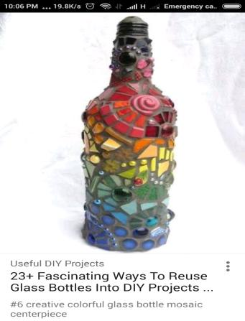

Vedpath

1. निम्नलिखित चार्ट बनाइए।
2. हवन करते हुए चित्रों में दर्शाइए।
3. परोपकार पर श्लोक लिखिए।
4. विद्या पर पांच श्लोक लिखिए।
5. मित्र पर पांच श्लोक लिखिए।