DAV PUBLIC SCHOOL KHERA KHURD / BUDHPUR

School Website : davpskherakhurd.com , School Tel No. 01127844245 , 01127201930

SUMMER BREAK HOLIDAYS HOMEWORK

**Class-IV**

**English**

1. Write a story from panchantra . Circle the verbs with red colour and adjectives the blue colour. Make a list of the verbs and adjectives.

Write 10 unfamiliar words from the story and write their meanings.

1. Make a beautiful bookmark with a quotation.
2. Reading Task

Read pages 27, 28, 39 and 64 from your English Reader and complete the exercises.

हिंदी

१) दस पृष्ठ सुलेख हिंदी की एक्टिविटी फाइल में करें।

 २) आपके दवारा किये गए किसी यात्रा का अनुभव लिखिए।

 ३) भारत की विभिन्न ऋतुओं की जानकारी देते हुए कुछ संबंधित चित्र लगाइए।

  ४) बढ़ते प्रदूषण से हमारा वातावरण दूषित हो रहा हैं -- इस का कोई समाधान सोच कर लिखिए।s

**G.Sciecne:**

1. Paste pictures of seasonal fruits you find in summer season.
2. Write any two dishes made out of your favourite fruit of summer . Paste pictures also.
3. Paste pictures of some useful flowers with their uses.

All the holidays Homework should be done in your Science Activity file.

**Social Science**

1) Make a collage of different festivals of India. Find out the delicacies (special dishes) associated with the festivals. Write the dishes in a tabular form.

2) Write the names of two cities each which are famous for the following:

* Palaces
* Temples
* Beaches
* Wildlife
* Now locate the states on the political map of India in which these cities are situated .

**General knowledge**

1. Paste any 10 current affairs in English.( G.K note book)
2. Find out the names of traditional dishes of any 10 states of INDIA. List down the main ingredients of any three of them. (Also paste the pictures of the dishes. (G.K. note book)

**Computer**

*Make a chart of any one*

1. *Parts of computer*
2. *Types of browsers commonly used.*

*Take light green sheet use the sheet in landscape .The border of the sheet*

*should be of black color .*

**Music**

*Learn the following*

1. *Sargam 1,2,3,4*
2. *Bhajan E malik tere bande hum*
3. *DAV Anthem*
4. *Mantras*

**Art**

Make a key chain with wool and beads as given in the picture

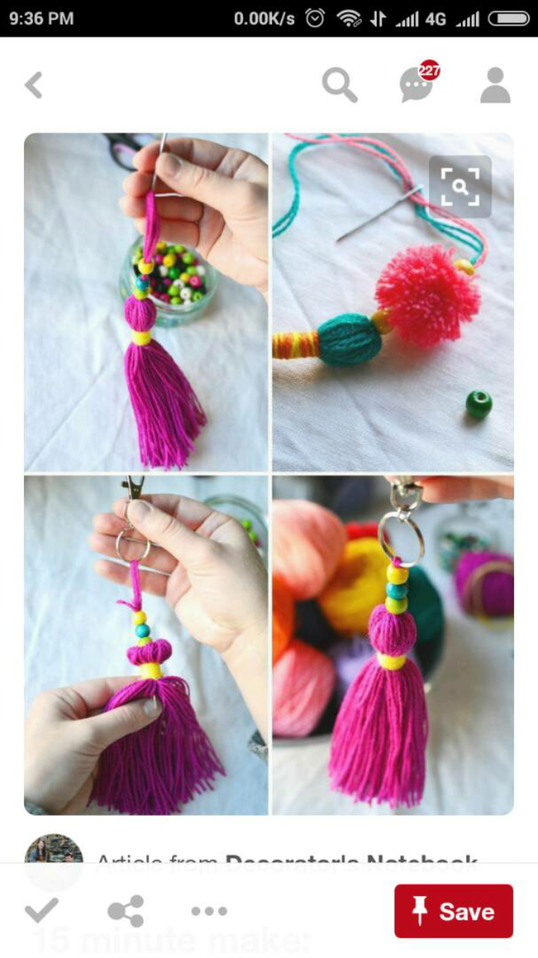



**Maths**

Q1. Learn and write tables from 1 to 20

Q2. Make a mini Mathematics dictionary using waste paper or old greeting cards. Pick up 20 words used in Mathematics and write them down along with their meaning. ( You may refer to your mathematics book)

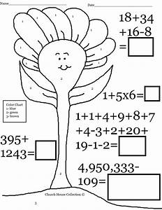Q3.

