DAV PUBLIC SCHOOL KHERA KHURD / BUDHPUR

School Website : davpskherakhurd.com , School Tel No. 01127844245 , 01127201930

SUMMER BREAK HOLIDAYS HOMEWORK 2018-2019

Class-III

**English**

1. Make a poster on “SAY NO POLYTHENE BAGS’ and write the harmful effects of polybags.(refer pg 59 of your English Reader)
2. Read one story from panchtantra. Complete the story map after reading the story

* Title
* Author
* Characters
* I like the story because ………….

1. Reading task

Read the pages 25-30 from English Reader and complete the exercises.

हिंदी

ग्रीष्मावकाश गृह कार्य

१) दस पृष्ठ  सुलेख हिंदी एक्टिविटी फाइल में करें।

२) कोई एक हिंदी की कहानी पढ़े और उस में से निम्नलिखित शब्द छाँट कर के लिखें ---

             क) ५ नाम वाले शब्द

             ख ) ५ काम वाले शब्द

              ग ) कहानी के मुख्य पात्र

               घ ) कहानी से मिली नैतिक शिक्षा

३) देश भक्ति और स्वच्छ ता  से संबंधित  एक  कविता याद करें और हिंदी एक्टिविटी फाइल में लिखें।

४) किसी भी जानवर का जैसे बिल्ली , हाथी, शेर आदि का एक मुखौटा बनाइए

५) वर्ण माला वर्ग सहित याद करें।

**G.Science**

Activity-1- Visit your neighbourhood and observe different types of nest of birds. Collect pictures of any four birds and their nests , name them and paste it in activity file.

Activity -2-Collect atleast four pictures of animals for each category and paste in different clouds as per their eating habits. Write their names too.

1. Carnivorous animals
2. Herbivorous animals

**General Knowledge :**

1. Find 10 endangered species of animals with their pictures. Paste them in G.K notebook.
2. Paste any 10 current affairs in English. (G.K Notebook)
3. Write full form of the following abbreviations. (In G.K Notebook )
4. IAF , ii) WWW , iii)ATM , iv) AMUL , v) RBI, vi )LS ,vii)CPU
5. CNG ix DMRC

**Social science**

1. Design a healthy plate for yourself, which should include all the nutrients essential for the

health of the children. Also list five steps that can ensure healthy eating habits. Sample given

below

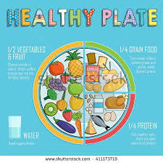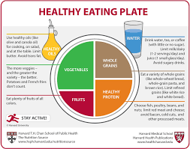

.

2) Make a list of  the people who help us to make our life comfortable and paste their pictures.

**Maths**

1. Learn the tables from 1 to 15.

2. Make a mini Mathematics dictionary using waste paper or old greeting cards. Pick up 10 words used in Mathematics and write them down along with their meaning. ( You may refer to your mathematics book)

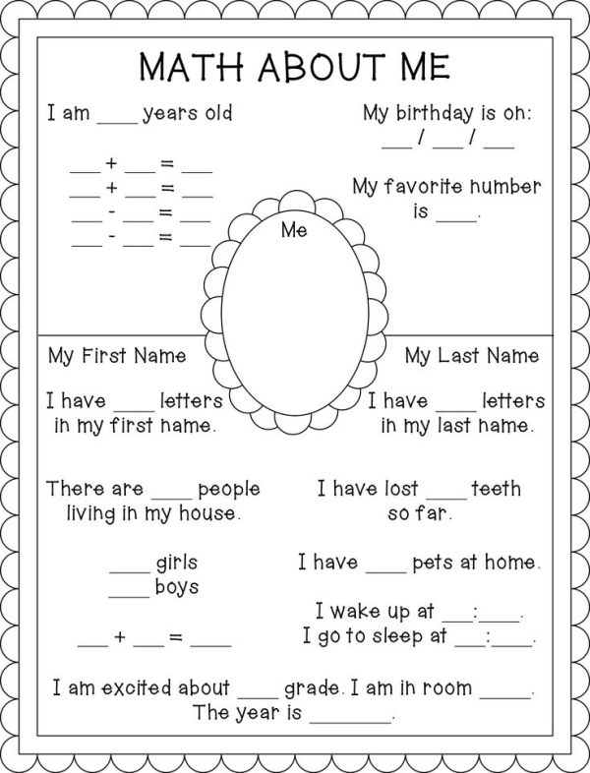Q3.

**Computer**

Make a chart of rules of how to work in a computer Lab.( Roll No. 1-10)

Make a Chart on different uses of computer. ( Roll No.11-21)

Vedpath

१ स्वामी दयाननद के जीवन पर आधारित दस पंक्तियाँ लिखिए।

२ गायत्री मंत्र अर्थ सहित स्मरण कीजिए।

३ प्रातः शाम १५ मिनट के लिए मैडिटेशन करें।

**Music:**

**Learn the following** :

1. Sargam 1, 2,3
2. Mantras
3. DAV Anthem

**Art**

Decorate the CD with stones and glitter tubes as shown in the picture.

