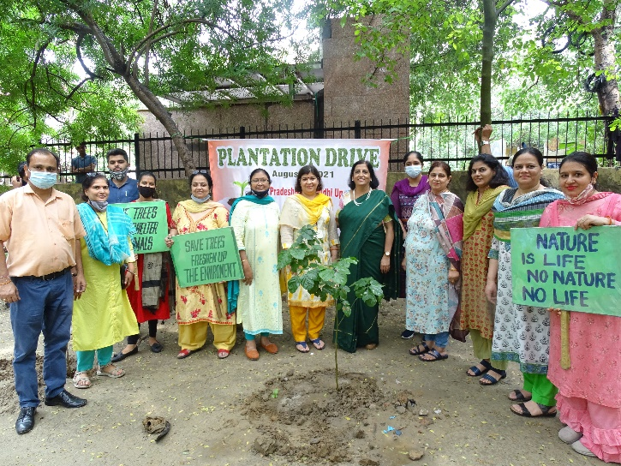
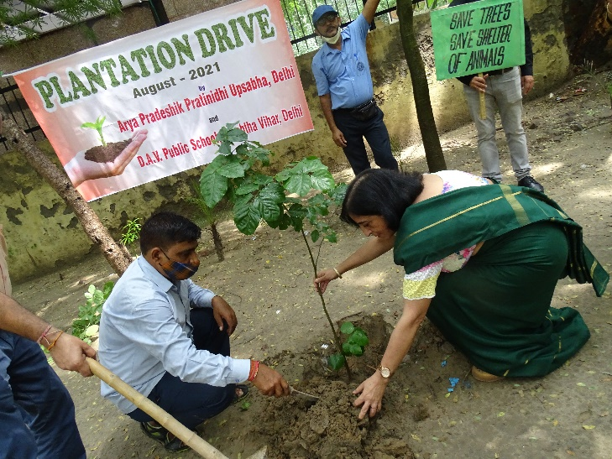
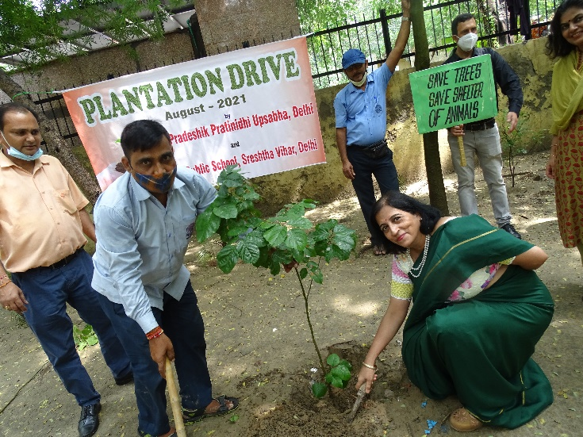
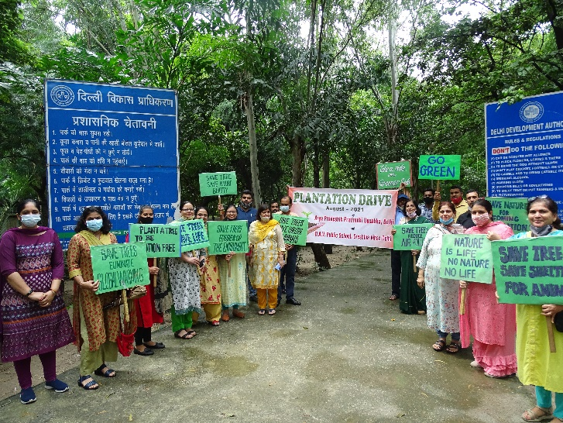
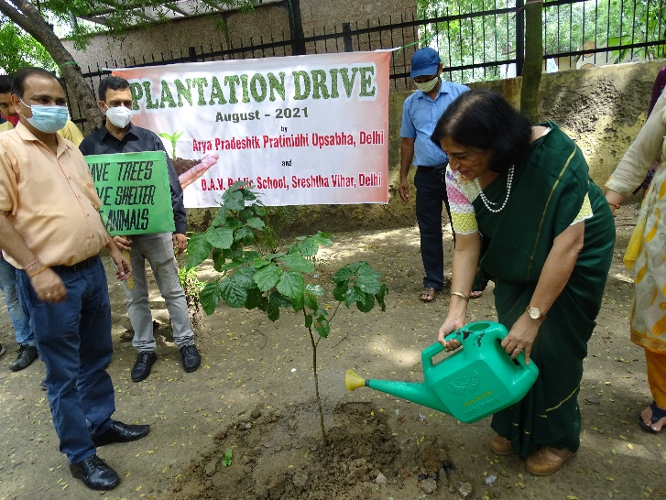
Our students are brought up in the true spirit of the DAV values and culture. Thus Havans and Shivirs are often held for their social and spiritual grooming. The school in true DAV spirit welcomes arya sanyasis and Vedic Vidwans and other spiritual leaders like Sri Sri Ravi Shankarji to spread the message of love, peace and humanity among the students of the school.Taking care of the students’ all round upbringing is also given immense importance. Hence, they are taught early in life to render social service and make charity their way of life. The students actively take part in various programmes and activities like green campaign, Bhagidari, Vanmahotsav or other social causes – they are there in all.The school’s resources are put to effective use through Chetna Kendra. This Kendra gives vocational training in the form of tailoring, beautician course, food preservation, mehendi art as well as computer literacy to the economically weaker children and women of the nearby localities. They get to be financially independent with these skills. Health rallies, road safety campaigns and cleanliness drives in the neighborhood are also undertaken by the students under the guidance of the teachers to create awareness.

